**CRM APPLICATION FOR JEWEL MANAGEMENT (DEVELOPER)**

**COLLEGE NAME : Tiruppur Kumaran College For Women**

**COLLEGE CODE : bru3j**

**TEAM ID : NM2025TMID28343**

**TEAM MEMBERS :**

* **TEAM LEADER : Uma Devi.M**

**EMAIL ID : umadevims29@gmail.com**

* **TEAM MEMBER : Thenmozhi.K**

**EMAIL ID : kthenmozhi256@gmail.com**

* **TEAM MEMBER : Vijayadharshini.K**

**EMAIL ID : vijayadharshinik2785@gmail.com**

* **TEAM MEMBER : Tamil selvi.P**

**EMAIL ID : ts6950809@gmail.com**

**1. INTRODUCTION**

**1.1 PROJECT OVERVIEW**

This CRM application is a software solution designed to streamline the processes of a jewel business. It manages customer relationships, sales, and inventory to improve efficiency and enhance the customer experience.

**1.2 PURPOSE**

The main objective of the application is to:

* Increase customer satisfaction and loyalty.
* Provide data-driven insights for better decision-making.
* Reduce manual effort and human errors in daily operations.

**2. DEVELOPMENT PHASE**

**2.2 Creating Development Phase**

By using this URL [**https://developer.salesforce.com/developer-legacy/signup**](https://developer.salesforce.com/developer-legacy/signup)

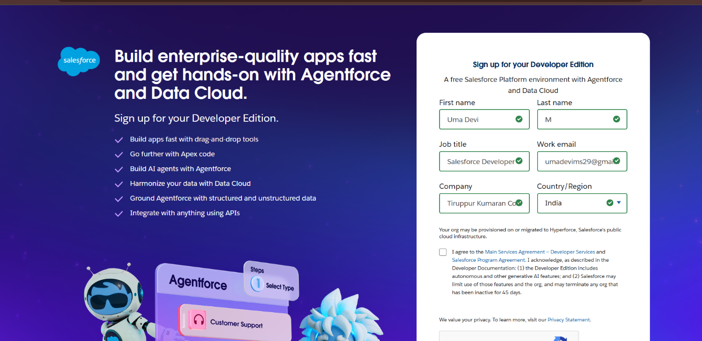

**3. OBJECTS**

* **Created Objects : Jewel Customer, Item, Customer, Order, Price and Billing**

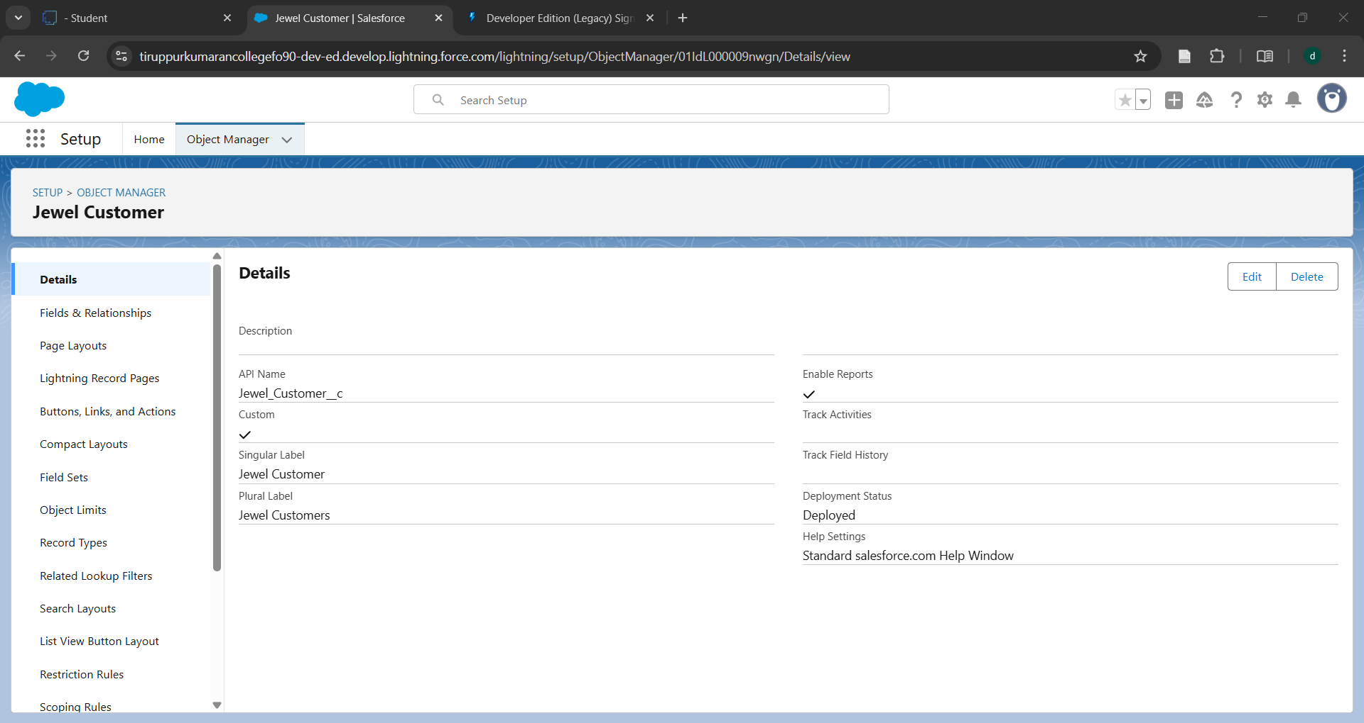

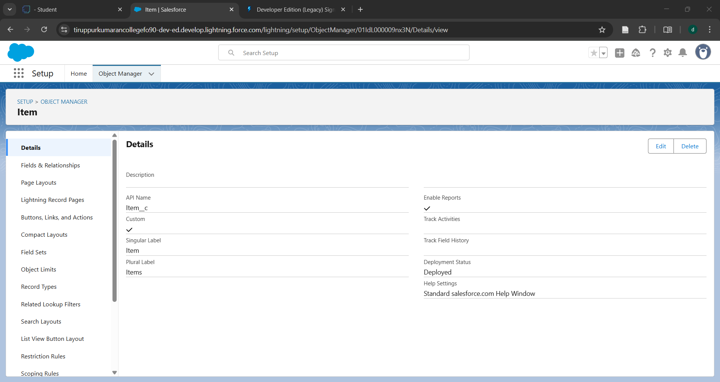

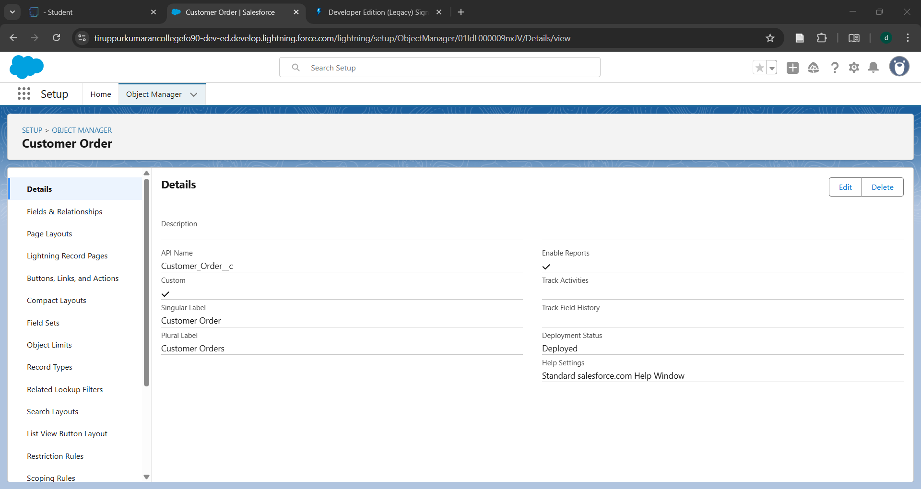

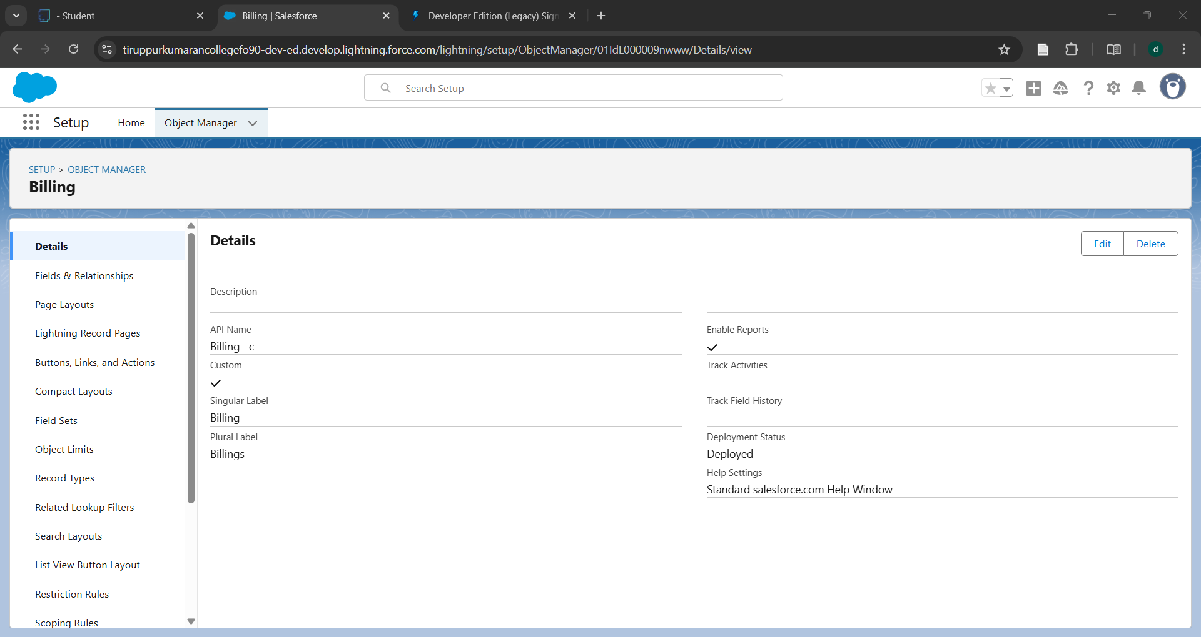

**4. TABS**

* **Created tabs : Jewel Customer, Item, Customer, Order, Price and Billing**

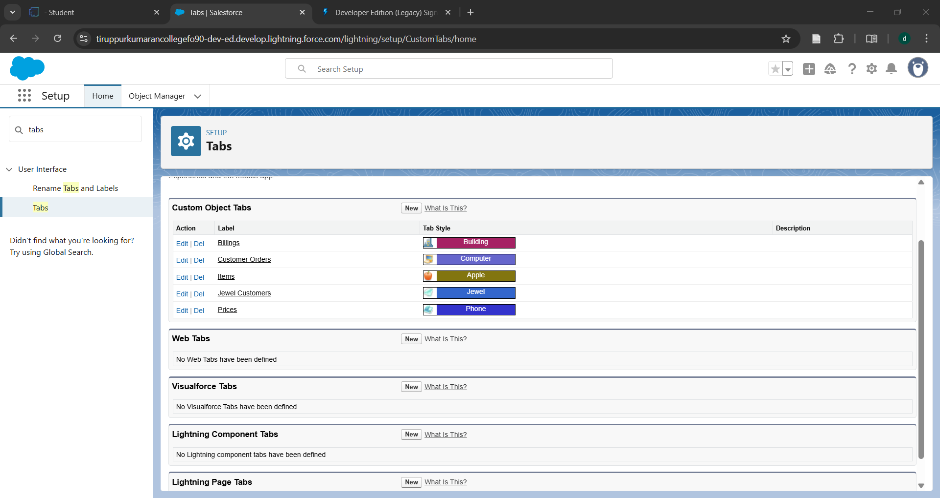

**5. THE LIGHTNING APPS**

* Developed lightning apps using relevant tabs

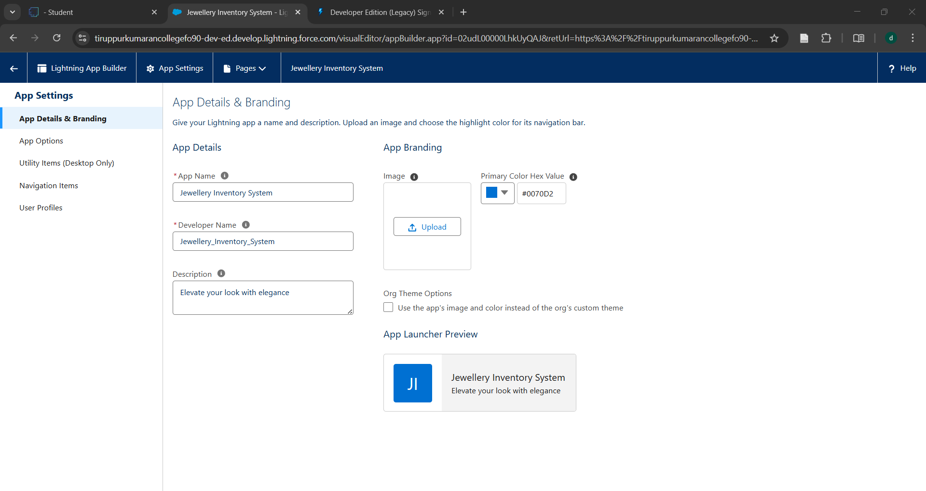

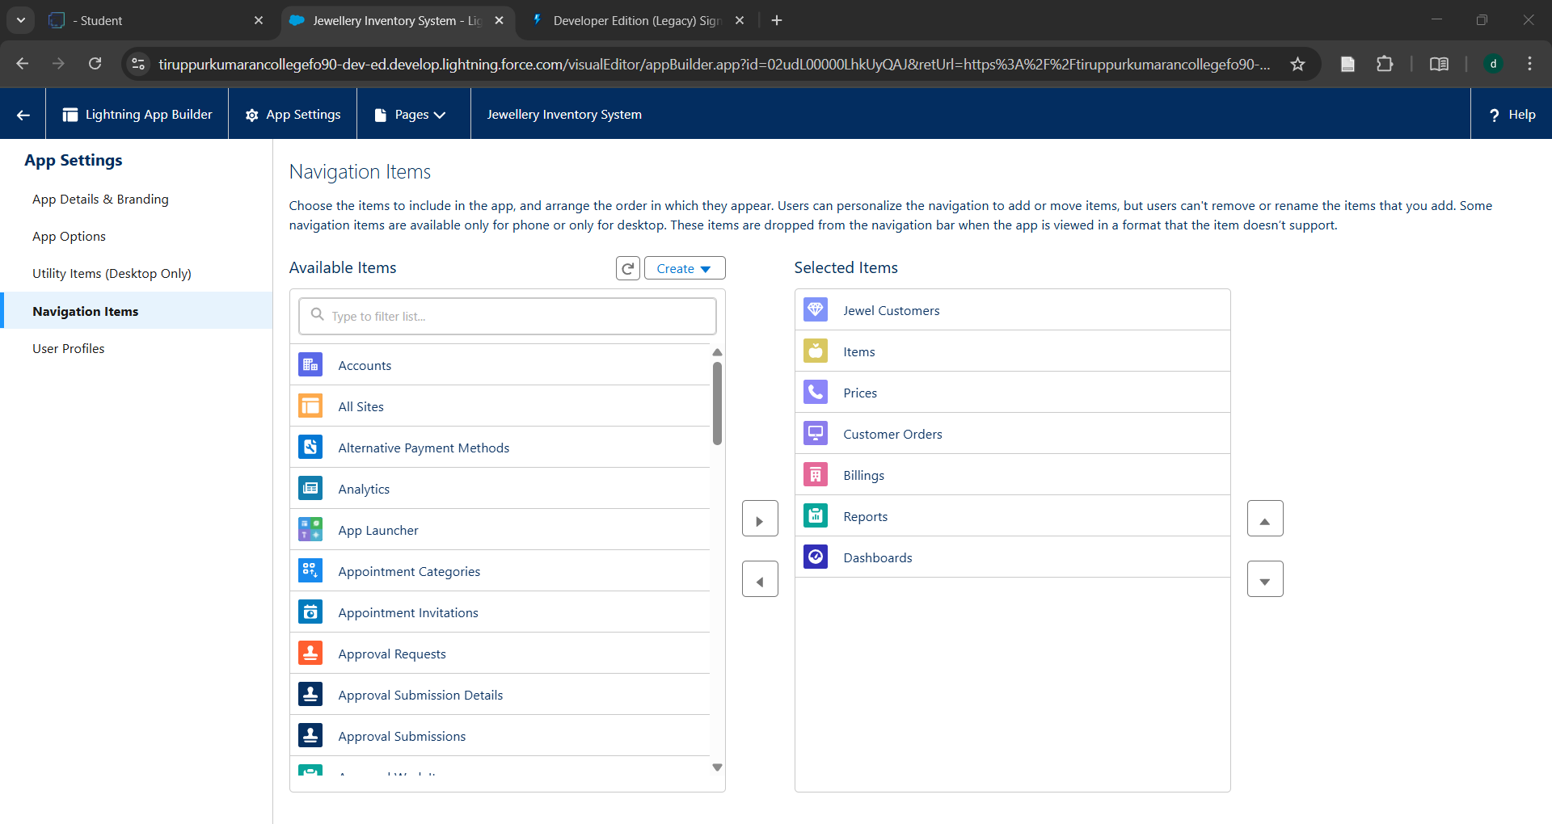

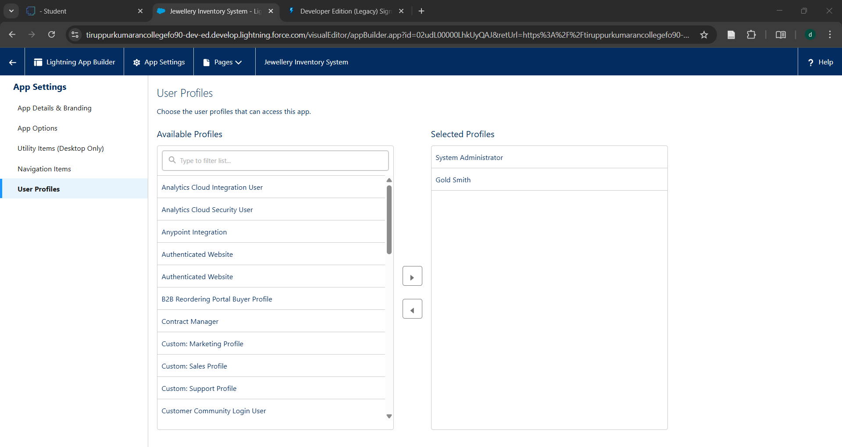

**6. FIELDS AND RELATIONSHIPS**

* Configured fields and relationships

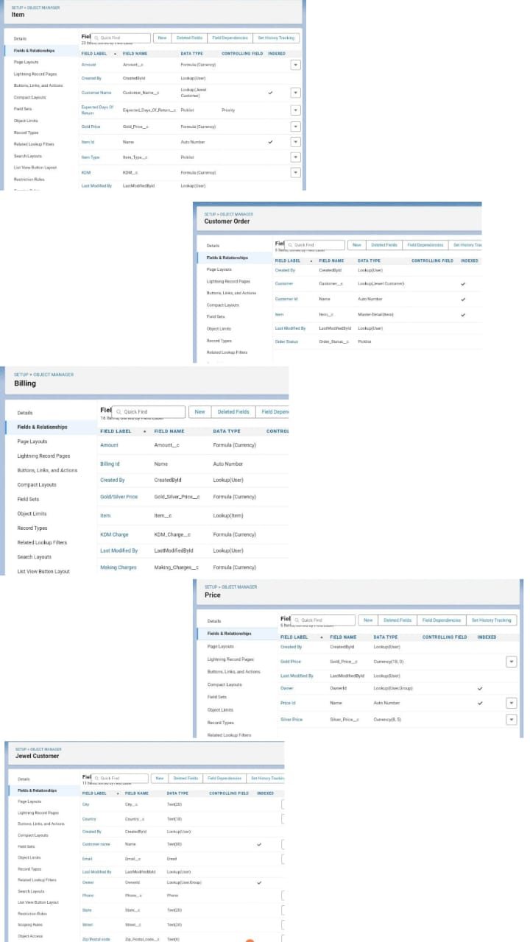

**7. FIELDS AND DEPENDENCIES**

* Created fields and dependencies for item

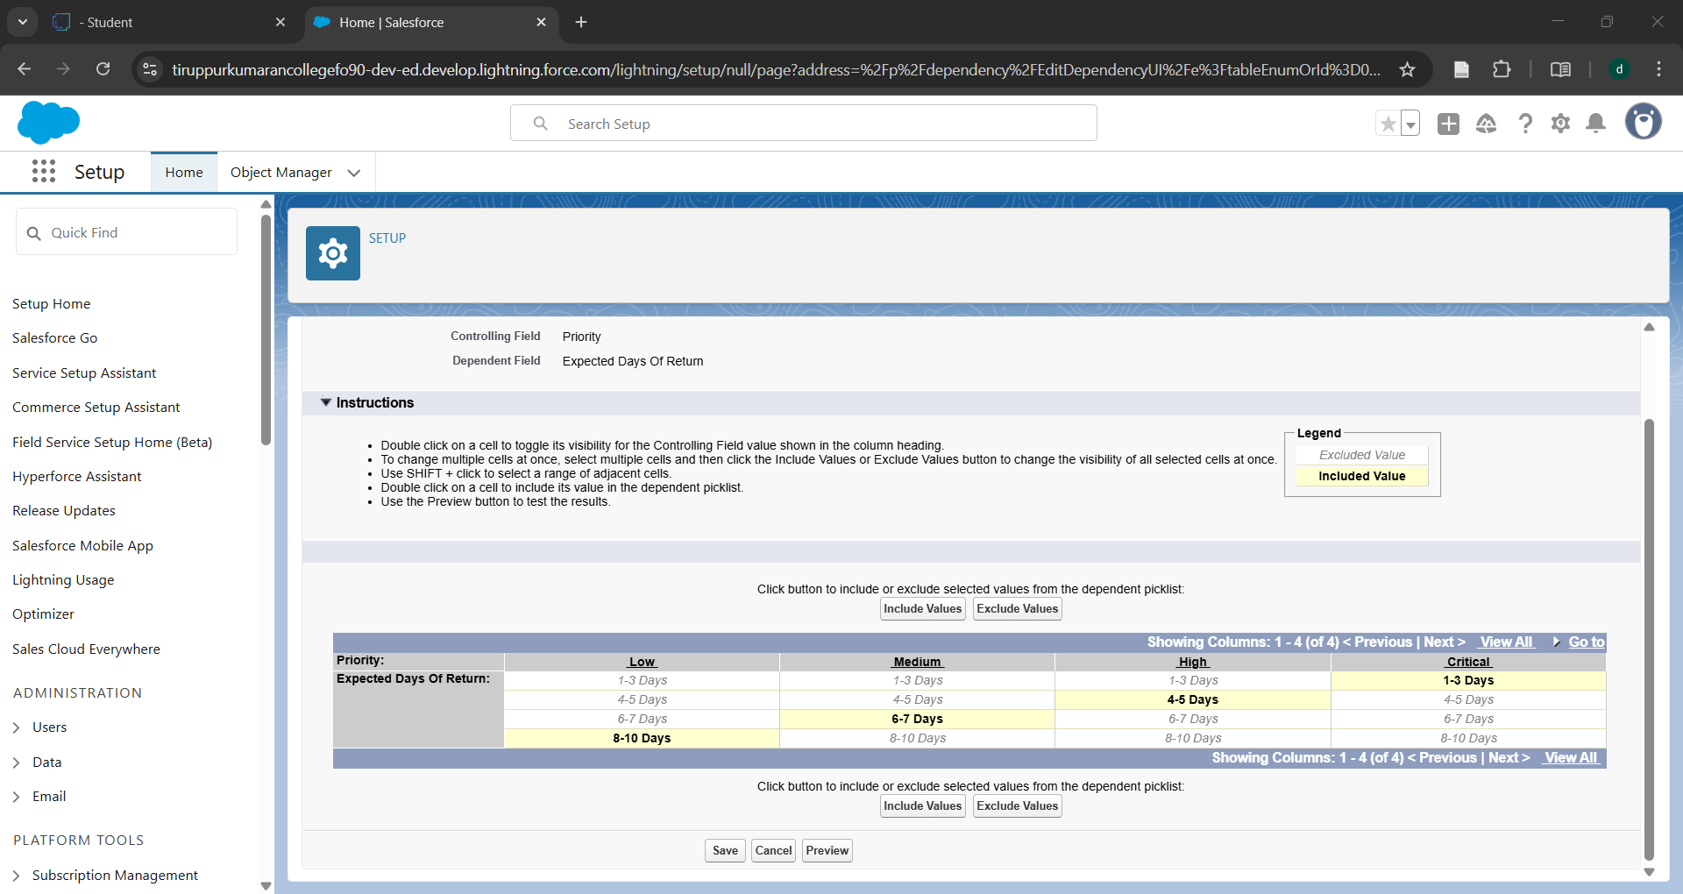

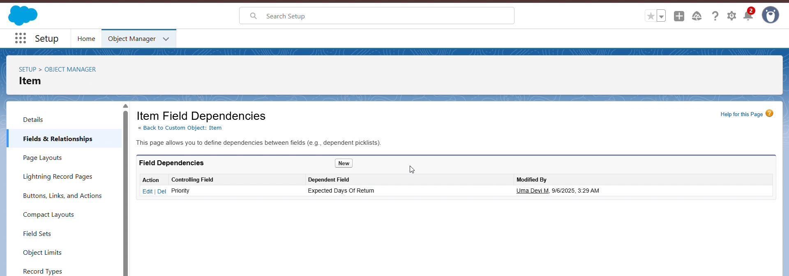

* Created validation rule for jewel Customer

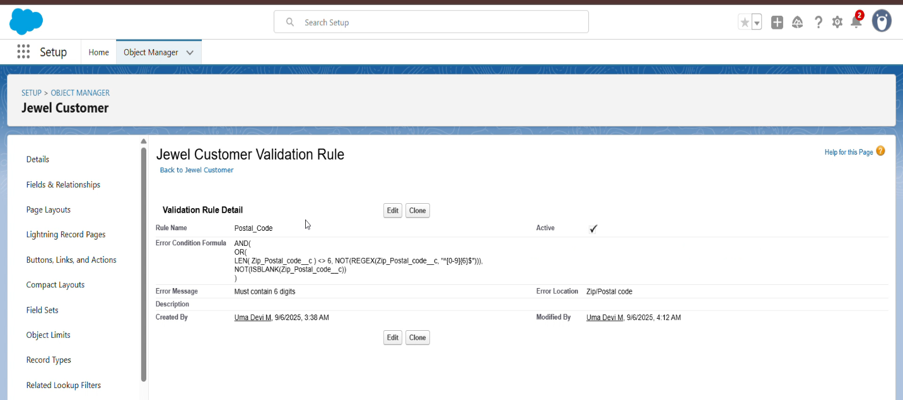

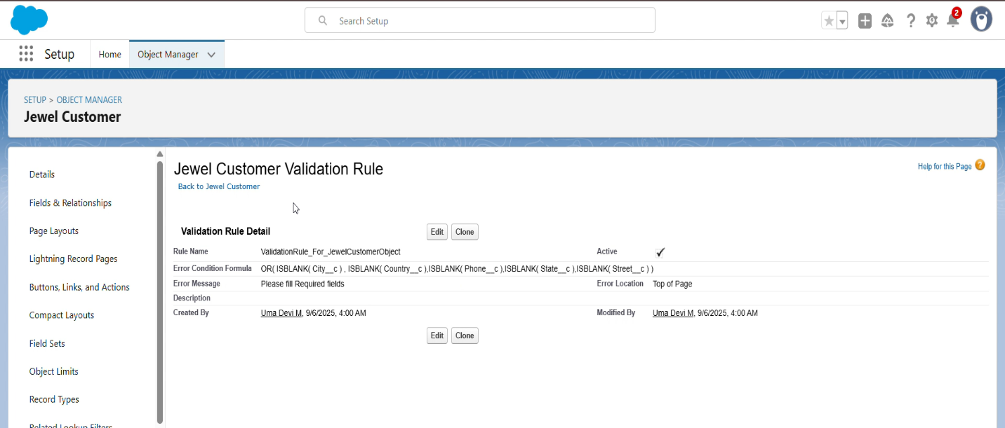

**8. PROFILES**

* Created profiles : Gold smith and worker profiles

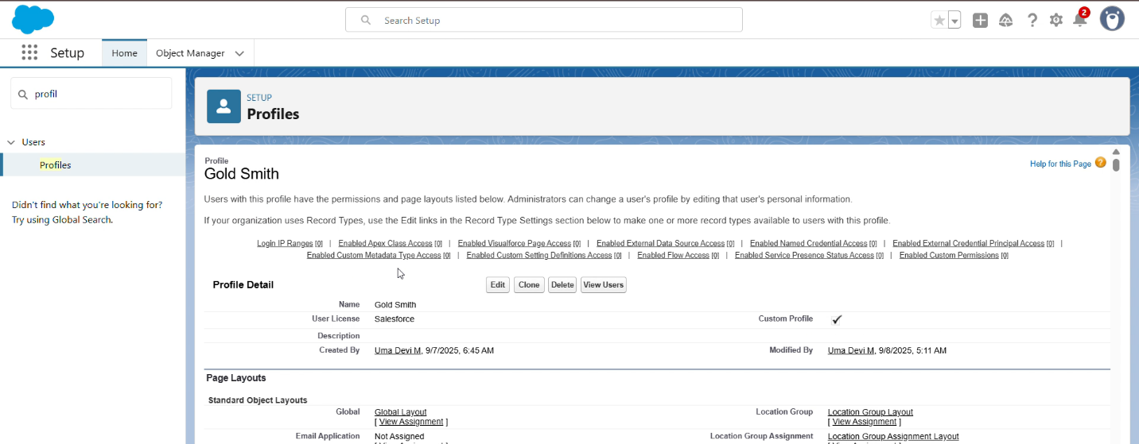

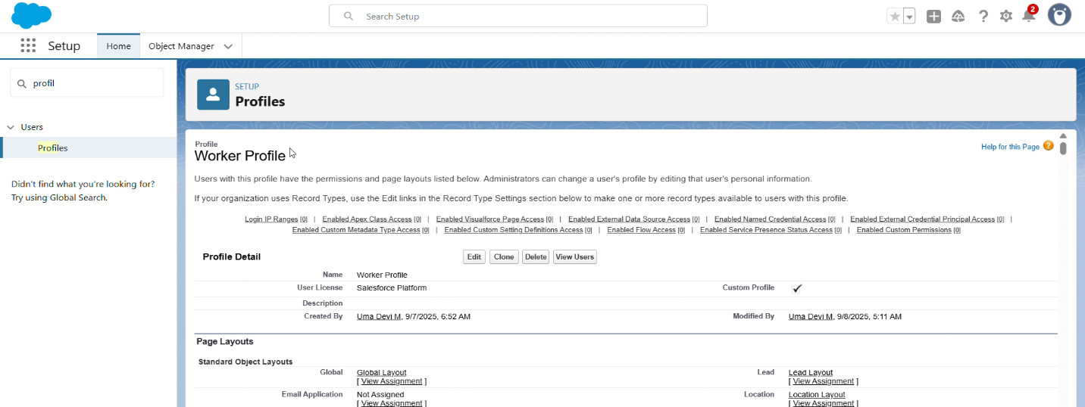

**9. ROLES**

* Created roles : Gold smith and Worker

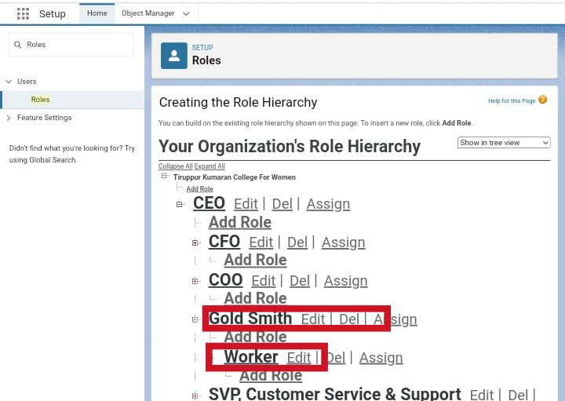

**10. USERS**

* Created users

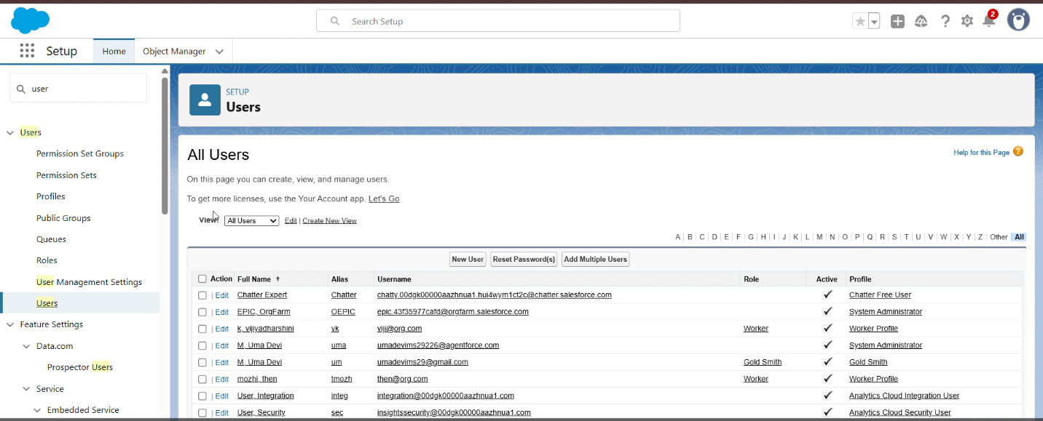

**11. PAGE LAYOUTS**

* Created page layouts:Gold page layout and silver page layout for item

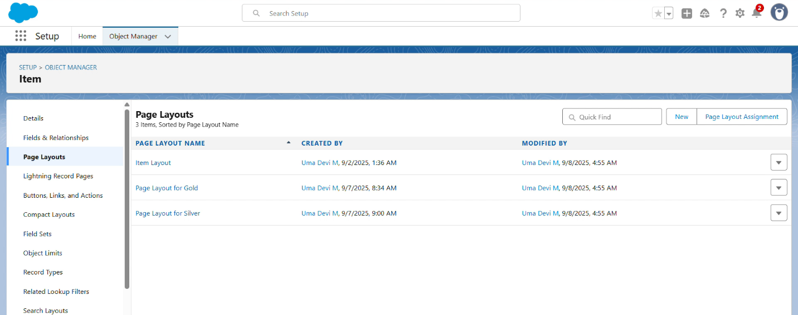

**12. RECORD TYPES**

* Created record types : Gold and Silver for item

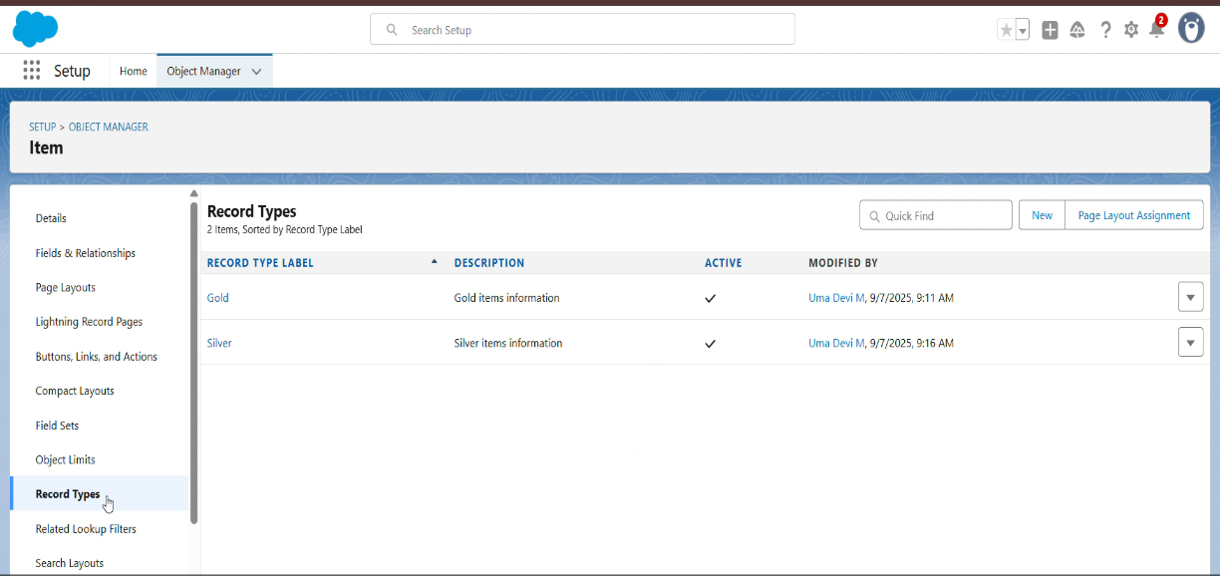

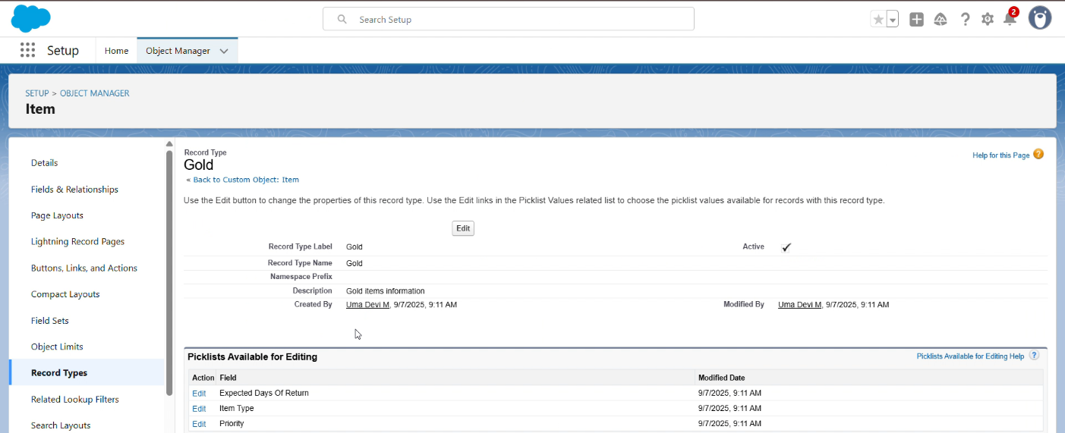

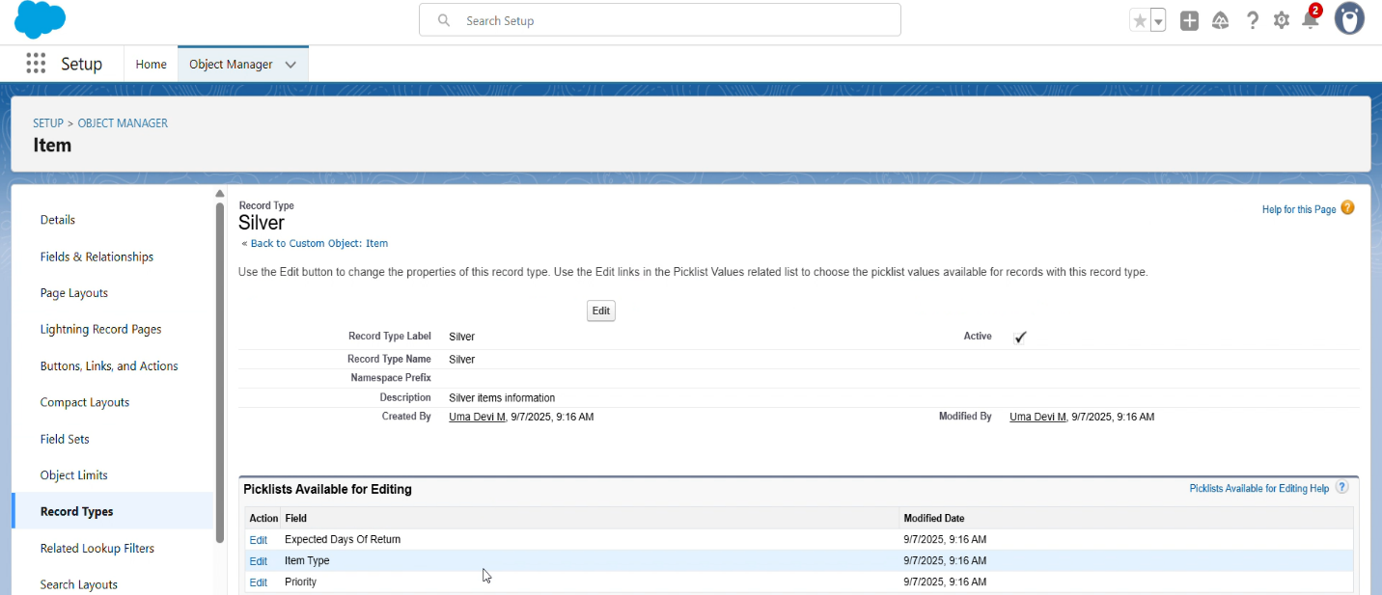

**13. PERMISSION SET**

* Created permission set : Per to Worker

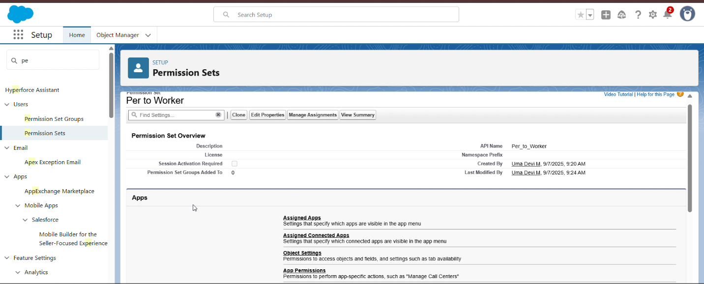

**14. TRIGGERS**

* Created a trigger handler class: UpdatePaidAmountTriggerHandler

UpdatePaidAmountTrigger

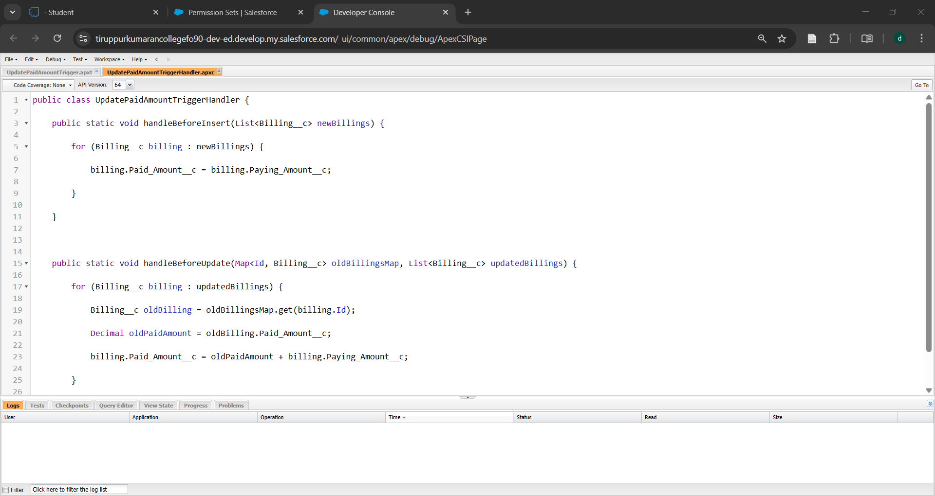

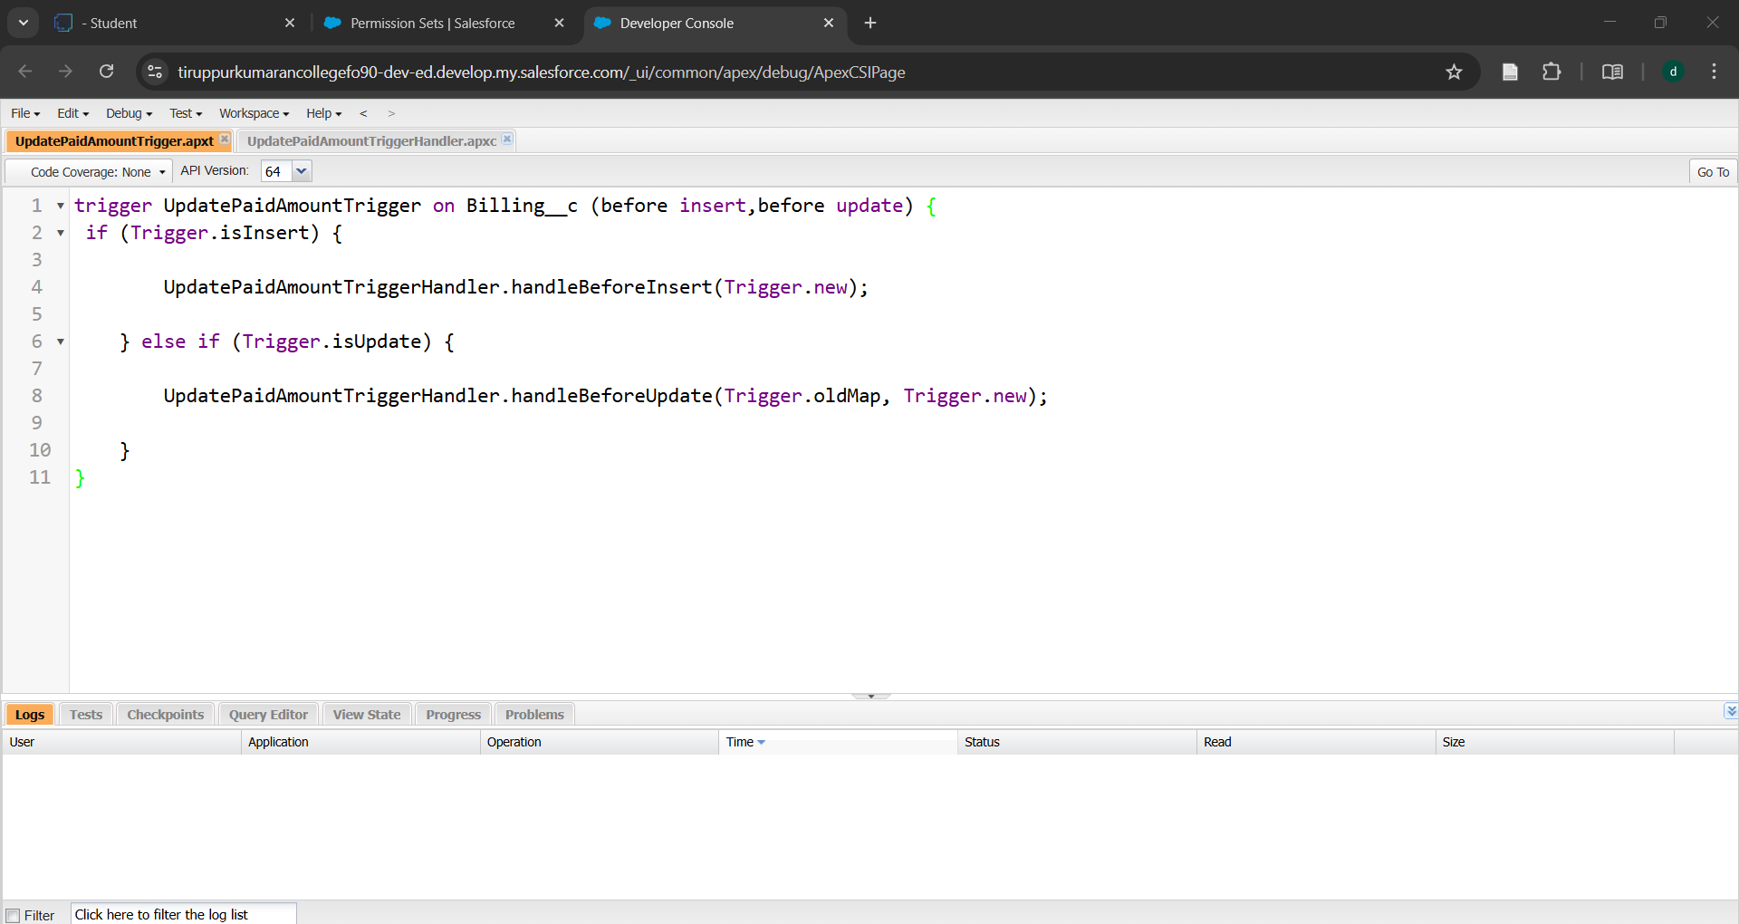

**15. USER ADOPTION**

* Created Record for Jewel customer in Jewel inventory system

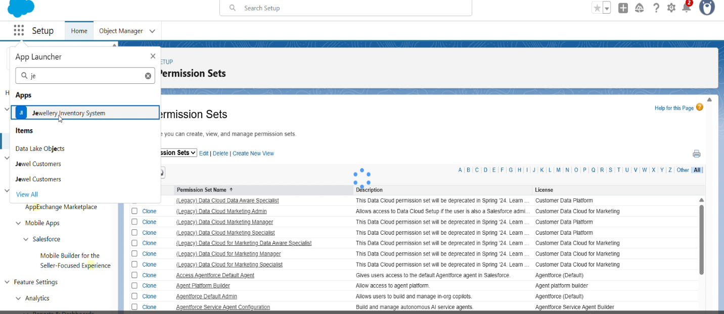

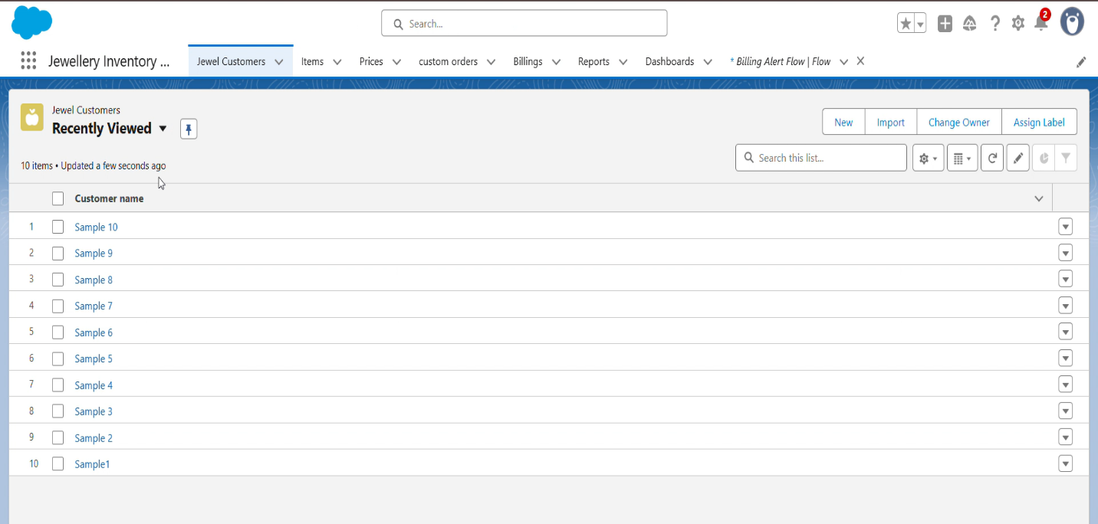

**16. REPORTS**

* Created Reports: Price, item with Billing, Billings with item and Costumer

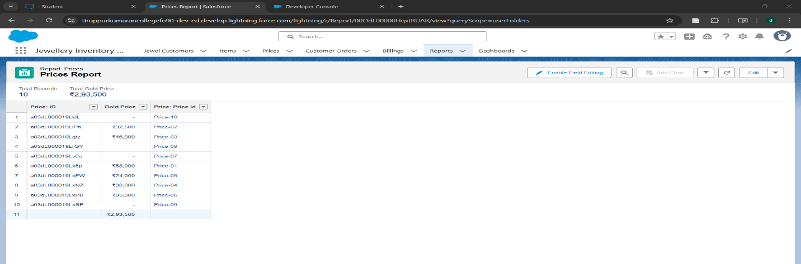

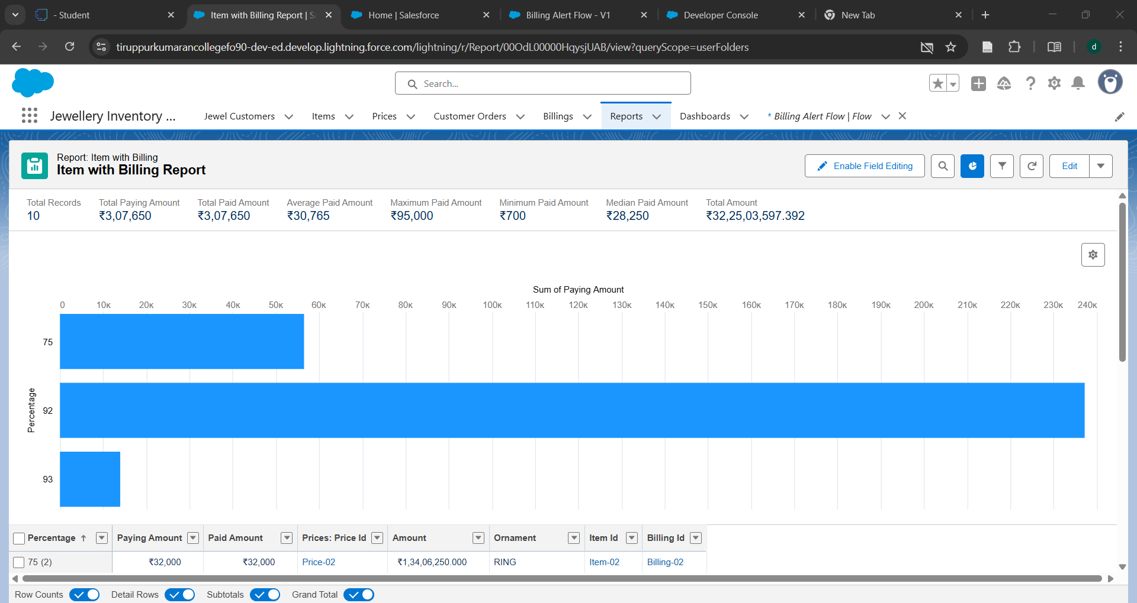

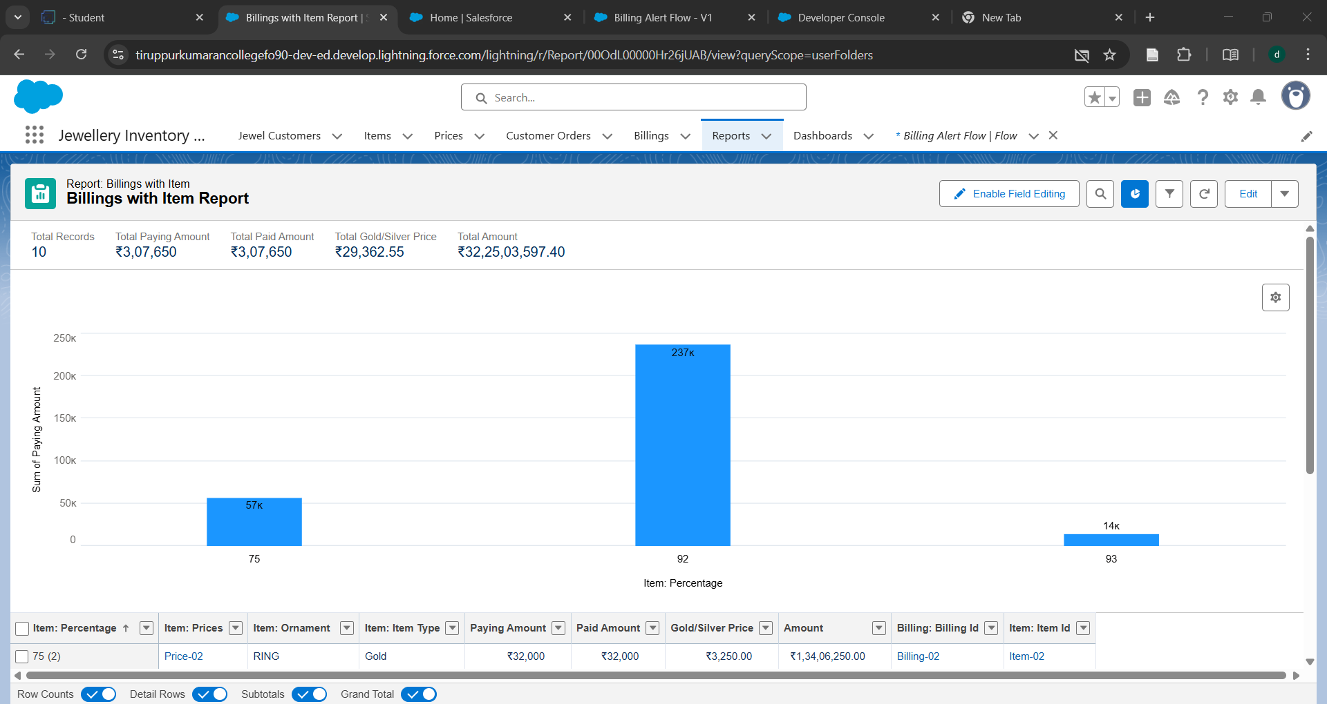

**17. DASHBOARDS**

* Created Dashboards for reports

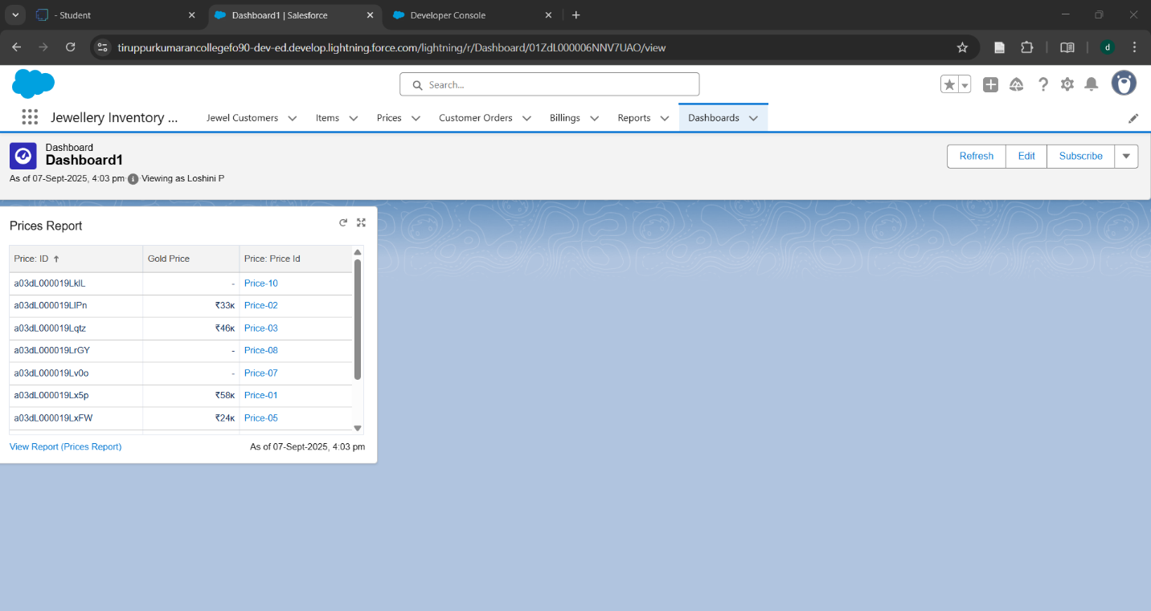

**18. FLOWS**

* Created Flow : Billing Alert Flow

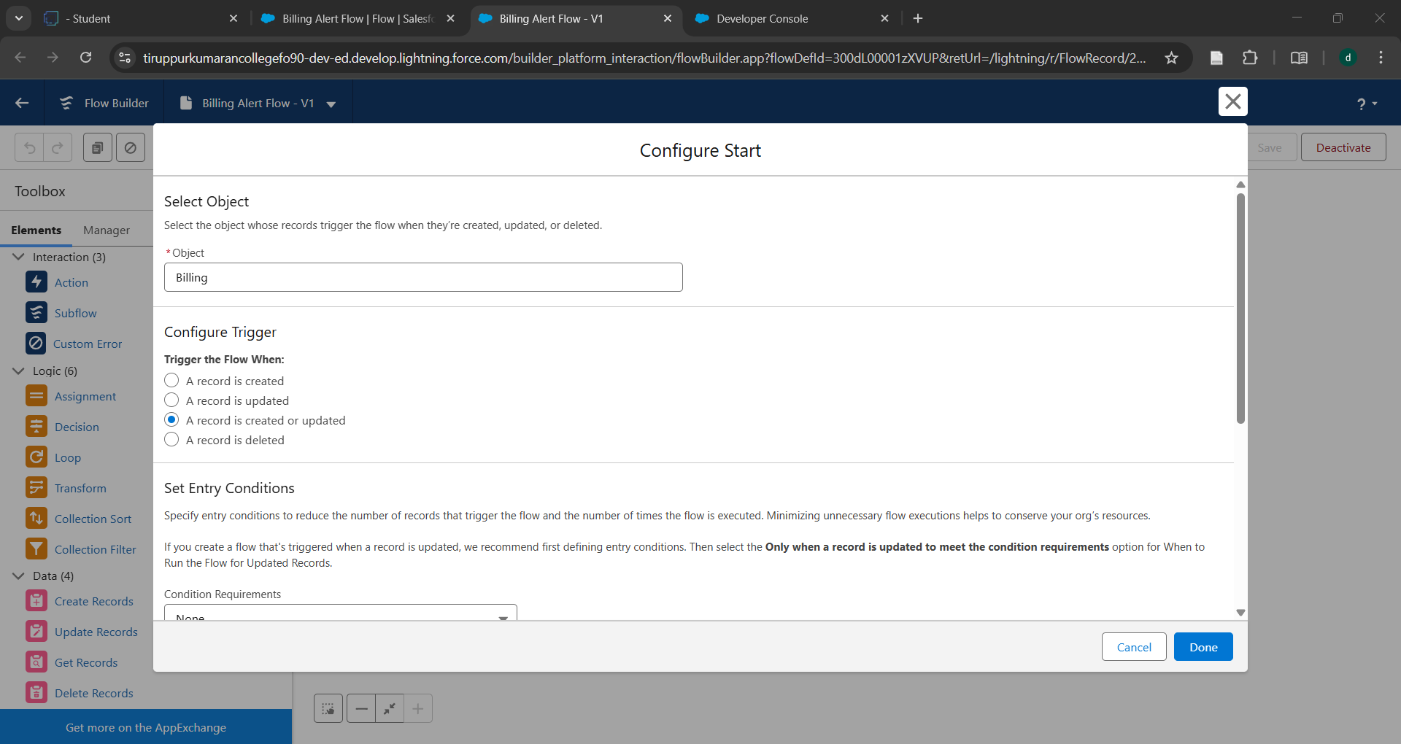

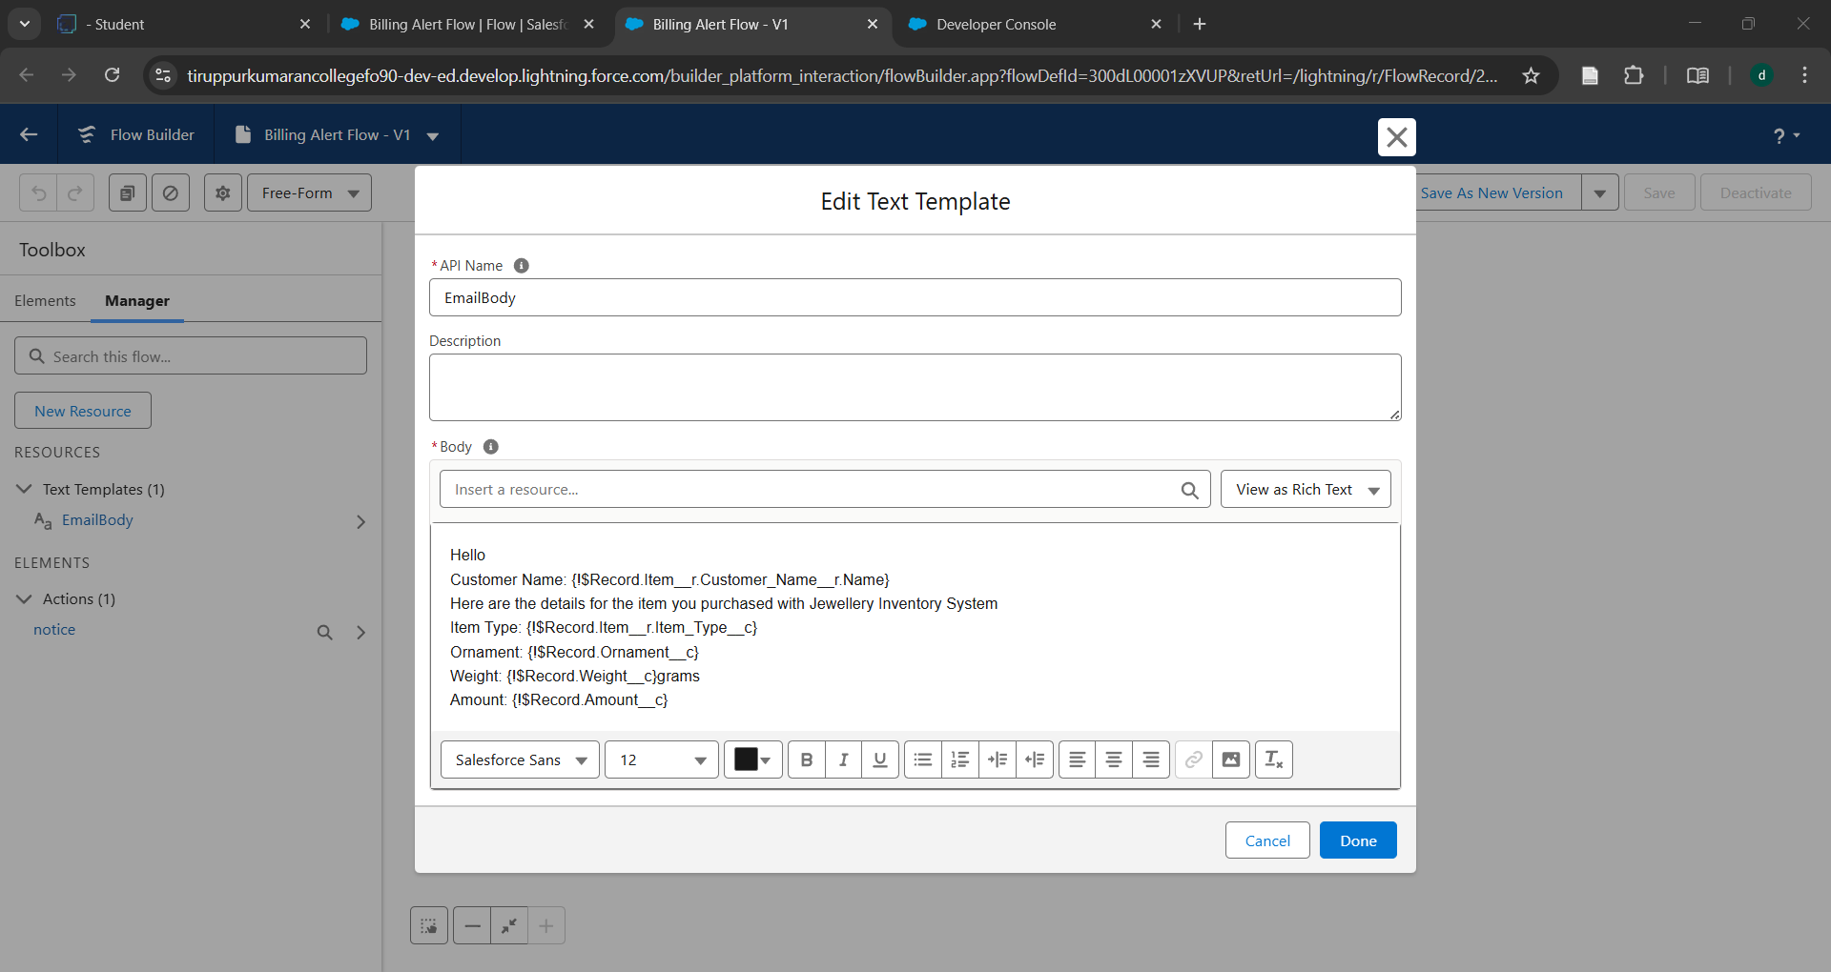

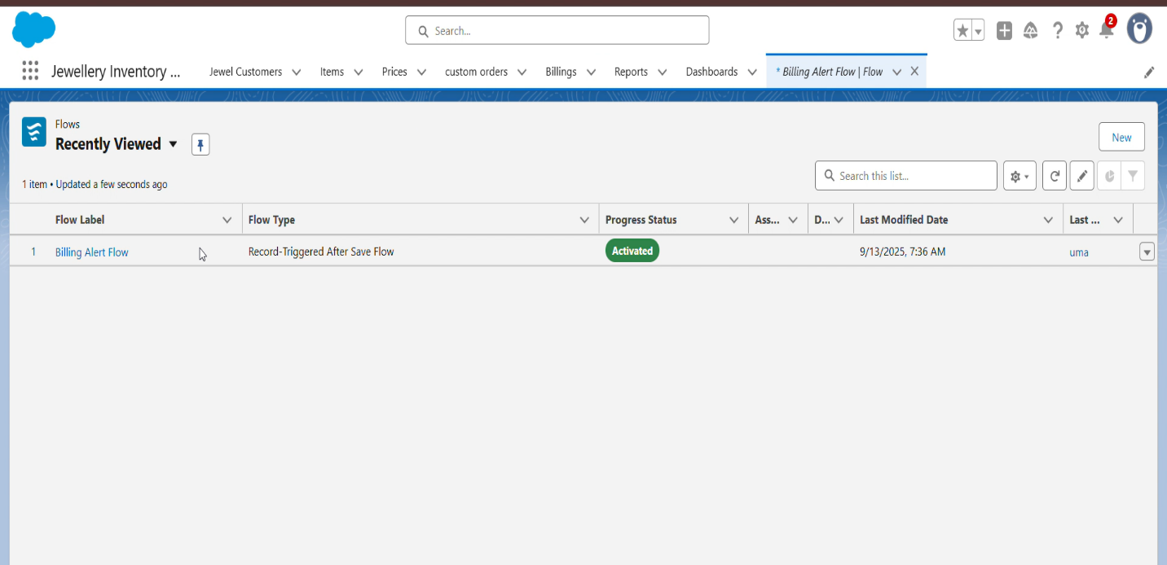

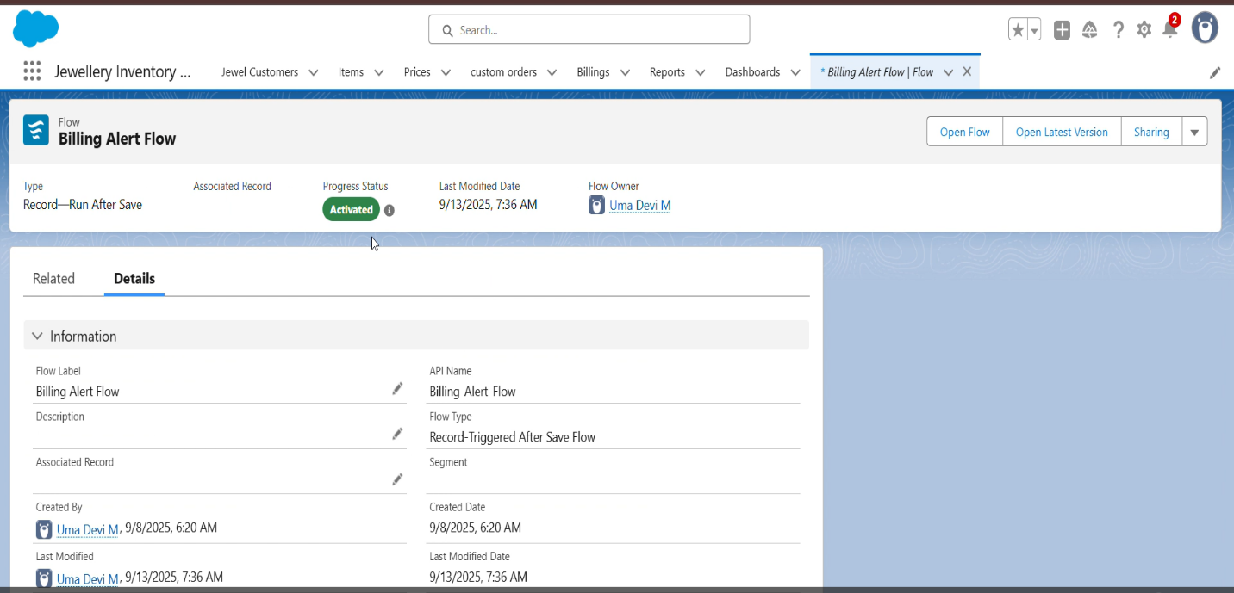

**RESULTS**

**OUTPUT SCREENSHOTS**

* Created records for jewel customer, billing , customer order ,price and item

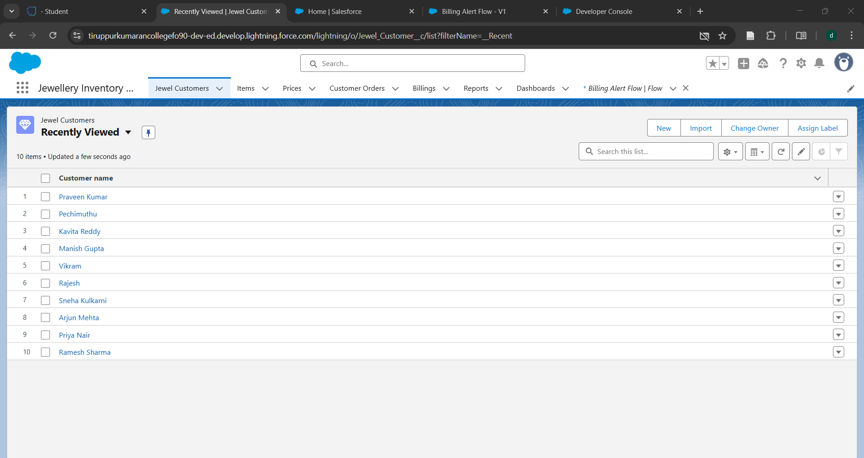

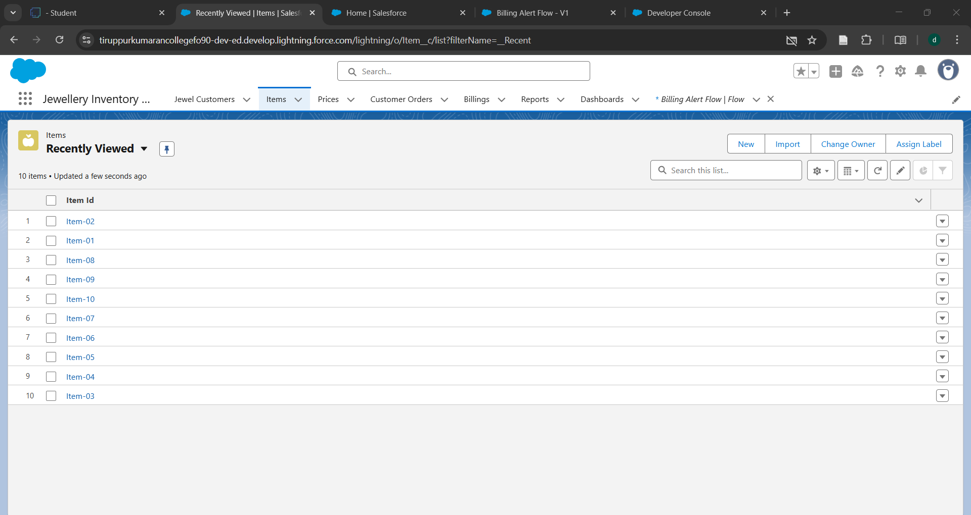

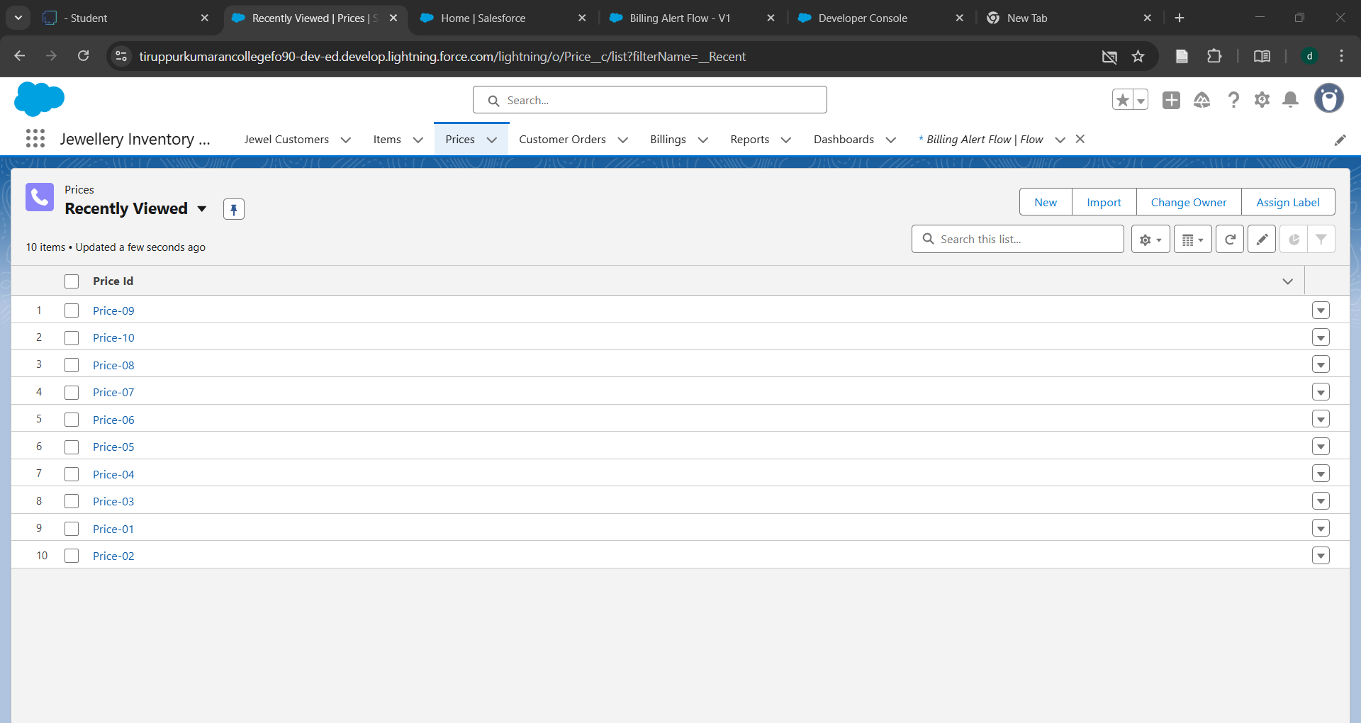

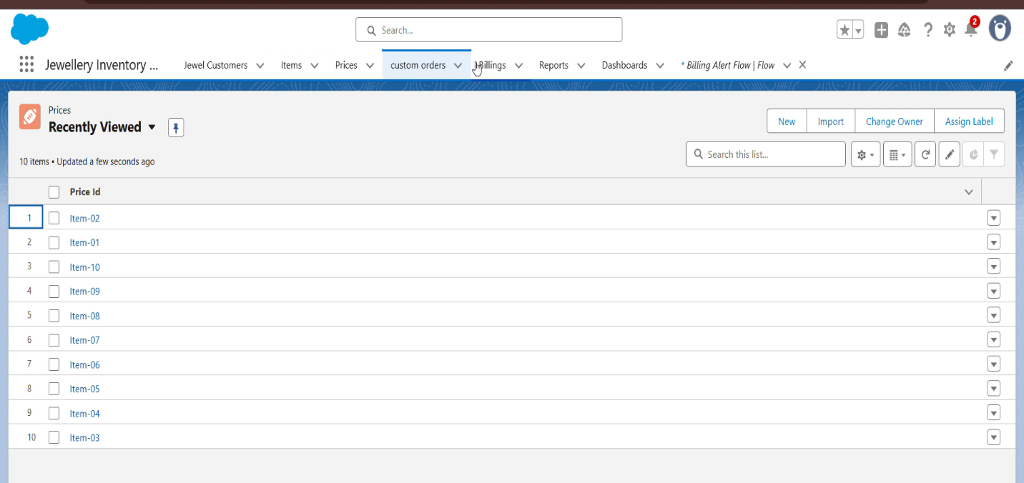

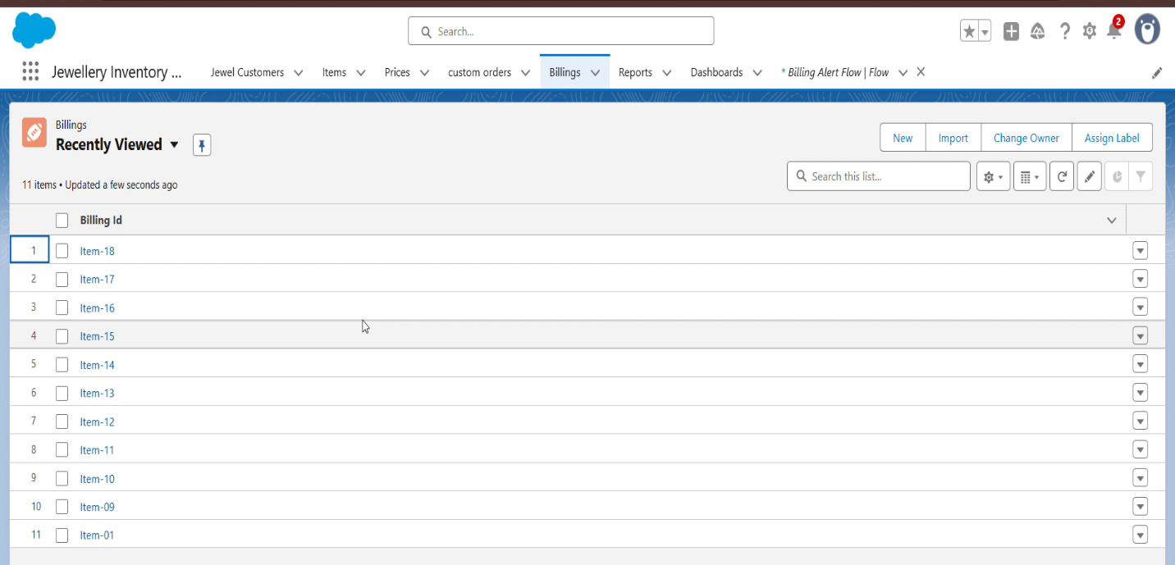

* Created reports and dashboards for jewel inventory system

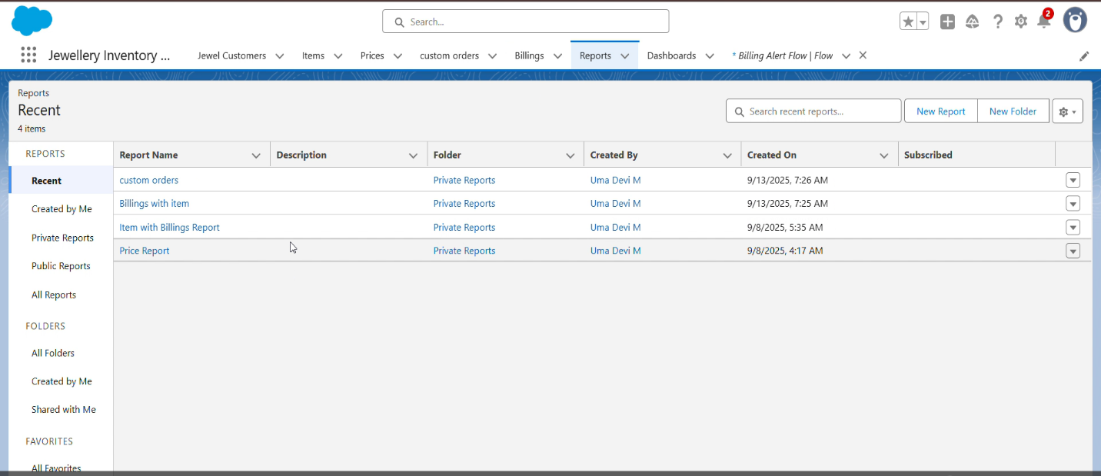

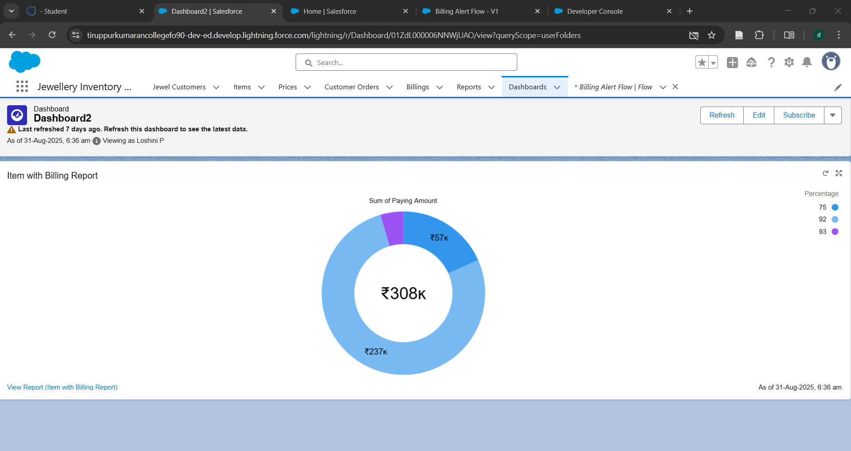

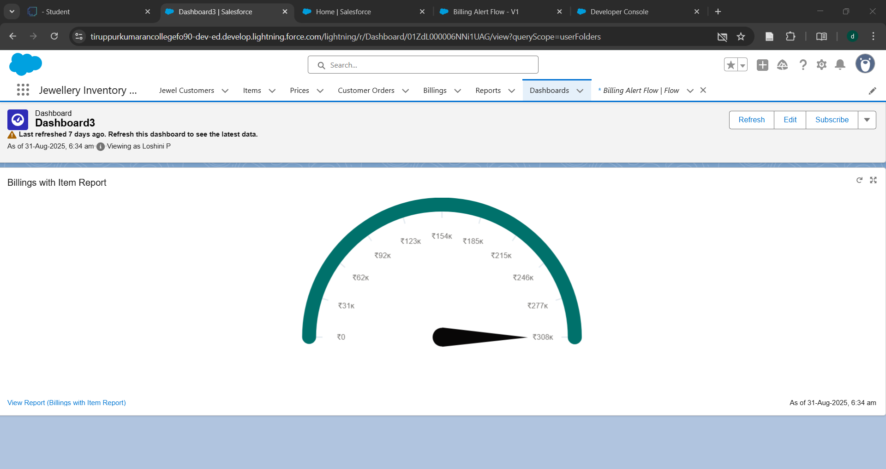

* Created flow output

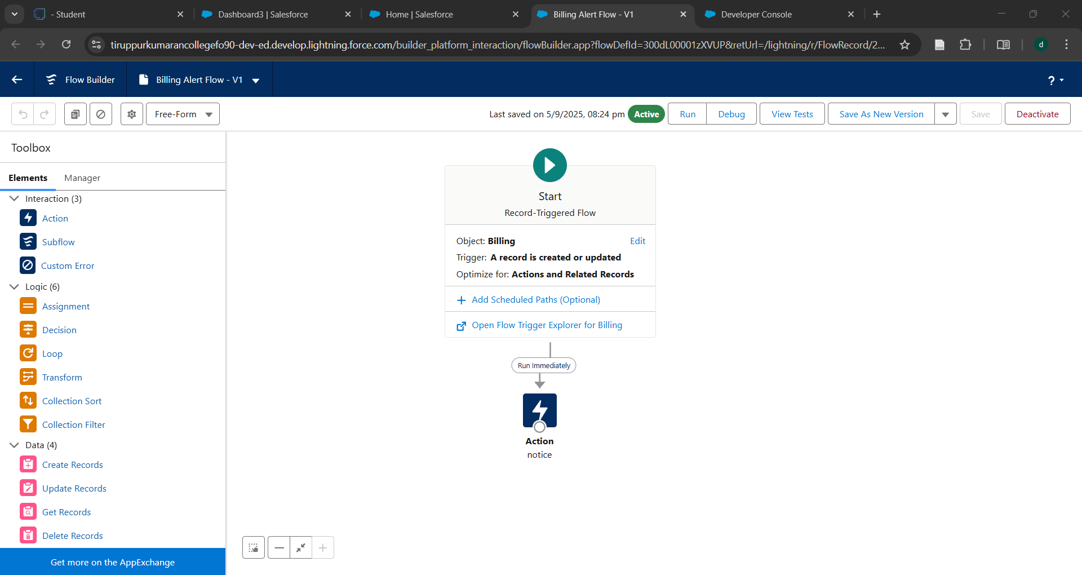

**CONCLUSION**

The CRM application for jewellery management effectively streamlines customer handling, sales, and inventory processes while enhancing customer relationships. It provides a reliable and scalable solution that supports business growth, improves efficiency, and strengthens customer loyalty in the jewellery industry.

**APPENDIX**

* **Source Code:** Provided in Apex Classes

Trigger handler:

 UpdatePaidAmountTriggerHandler

public class UpdatePaidAmountTriggerHandler {

    public static void handleBeforeInsert(List<Billing__c> newBillings) {

        for (Billing__c billing : newBillings) {

            billing.Paid_Amount__c = billing.Paying_Amount__c;

        }

    }

    public static void handleBeforeUpdate(Map<Id, Billing__c> oldBillingsMap, List<Billing__c> updatedBillings) {

        for (Billing__c billing : updatedBillings) {

            Billing__c oldBilling = oldBillingsMap.get(billing.Id);

            Decimal oldPaidAmount = oldBilling.Paid_Amount__c;

            billing.Paid_Amount__c = oldPaidAmount + billing.Paying_Amount__c;

        }

    }

}

UpdatePaidAmountTrigger

trigger UpdatePaidAmountTrigger on Billing__c (before insert, before update) {

    if (Trigger.isInsert) {

        UpdatePaidAmountTriggerHandler.handleBeforeInsert(Trigger.new);

    } else if (Trigger.isUpdate) {

        UpdatePaidAmountTriggerHandler.handleBeforeUpdate(Trigger.oldMap, Trigger.new);

    }

}